Chapter 19, Solution 94

We first obtain the ABCD parameters.
Given 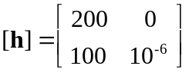, 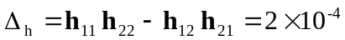

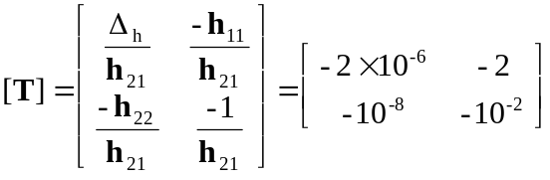

The overall ABCD parameters for the amplifier are
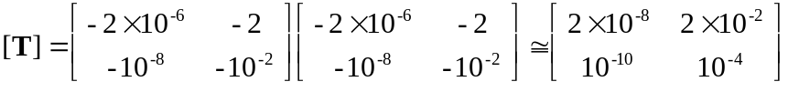

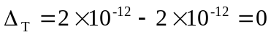

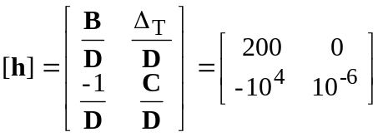

Thus, ,  